Abubakkar Abdullah

20p-0045

Section: Operating Systems BCS-4A

Lab Task: 1
------------------

“LS Command”
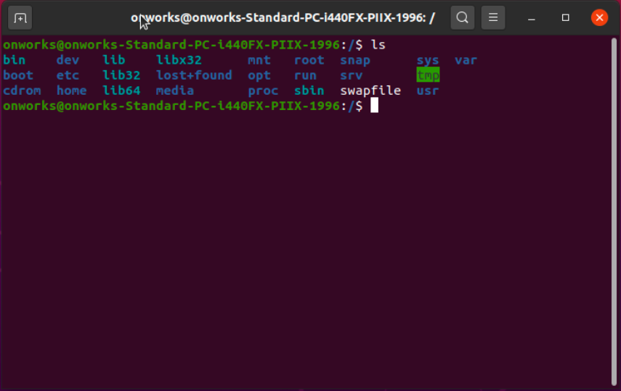
.
.
“MAN LS”
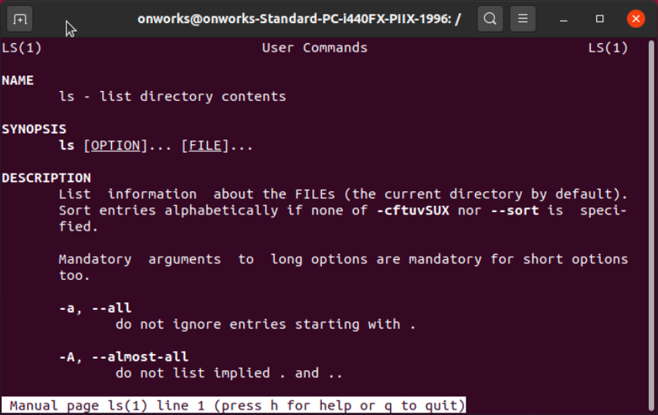
.
.
PWD Command

.
.
.
.
.
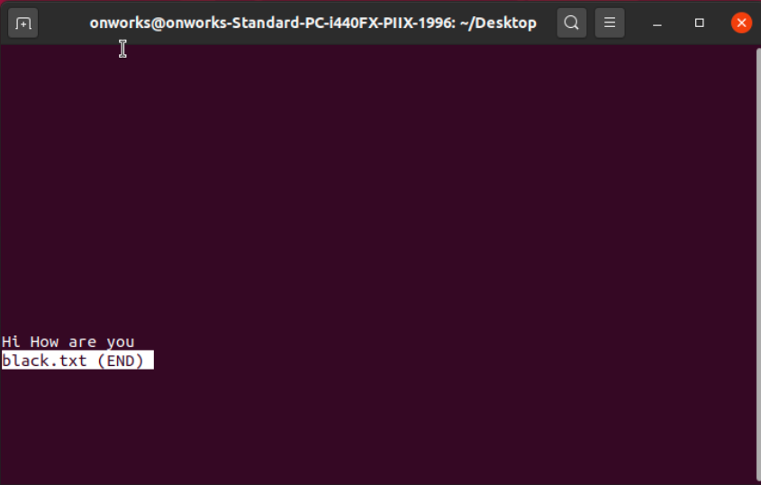
.
.
.
.
.
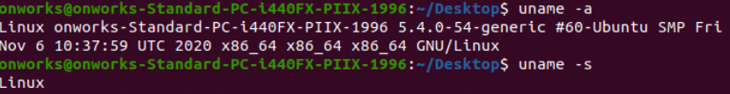
.
.
.
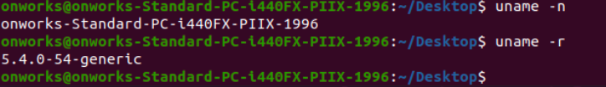
.
.
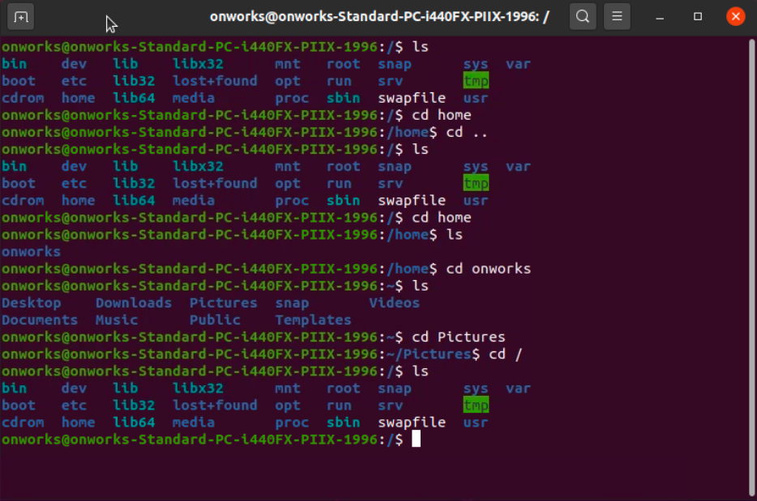
.
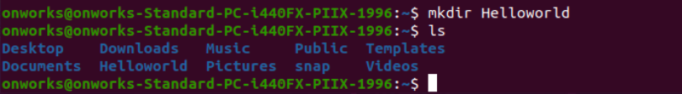
.
.
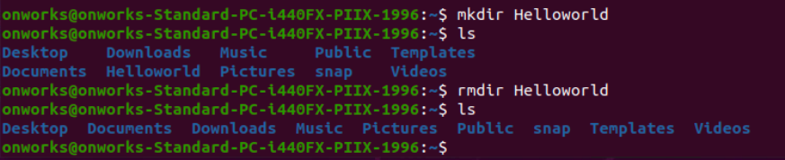
.
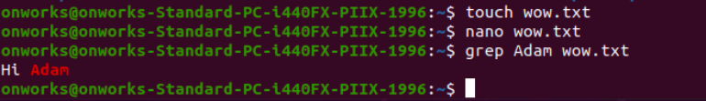
.
.
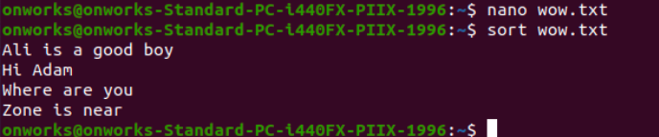
.
.
.
.
.
.
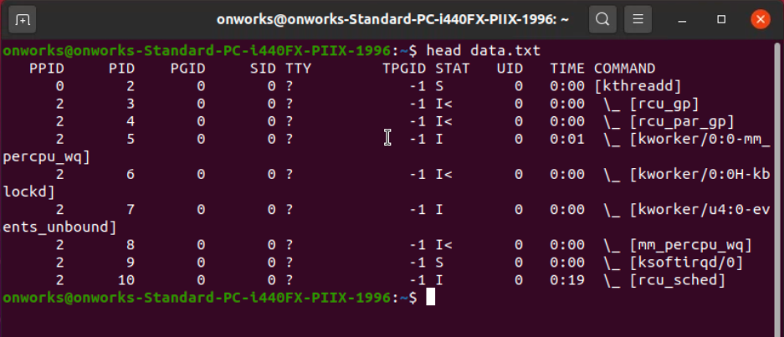
.
.
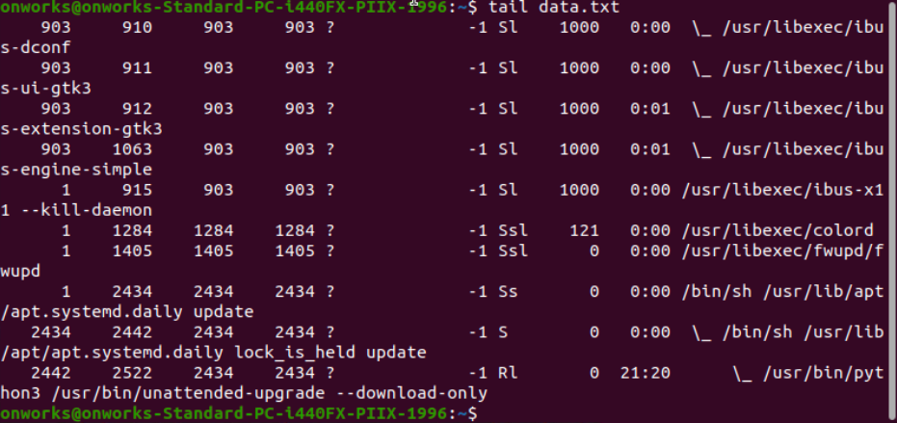
.
.
.
.
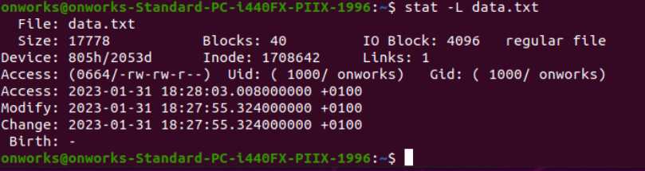
.
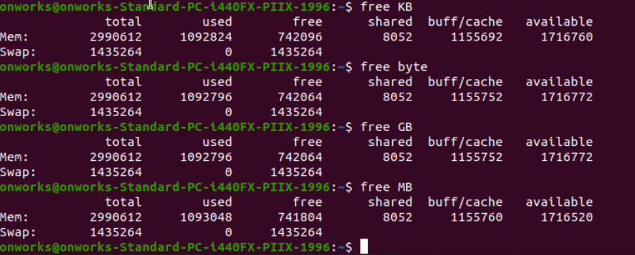
.
.
.
top:
.
.
.
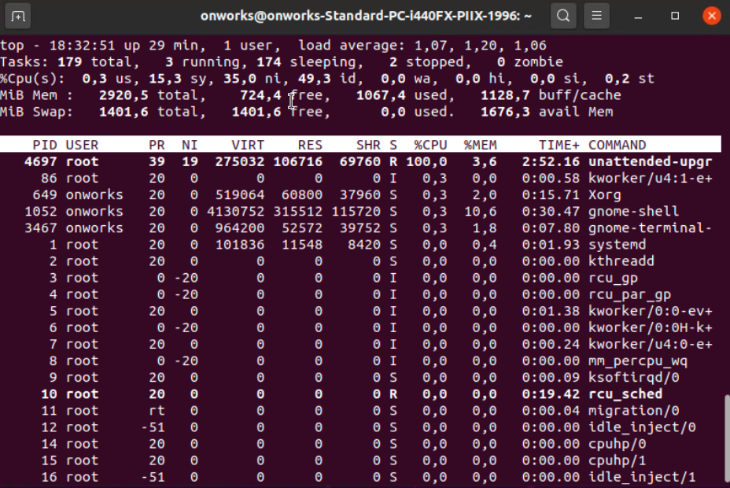
.
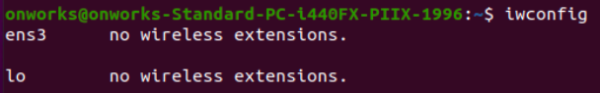
.
.

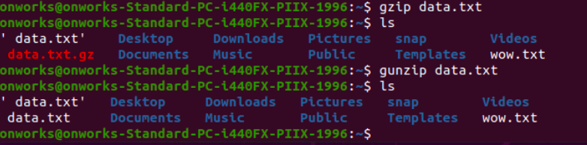
.
.
PING:
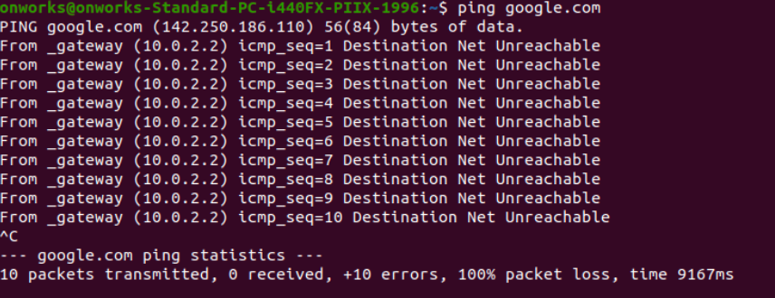
.
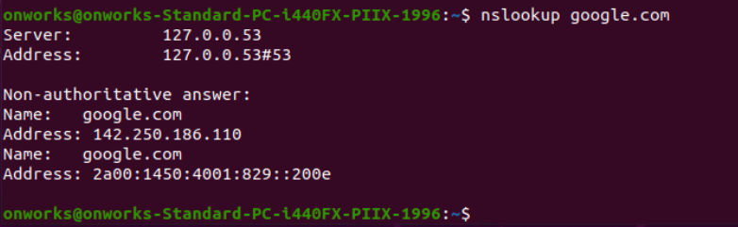
.
.
.
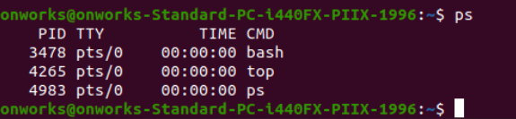
.
.
.
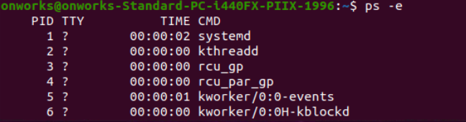
.
.
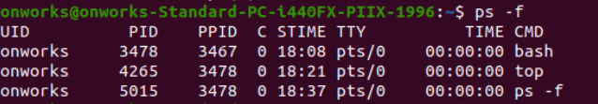
.
.
.
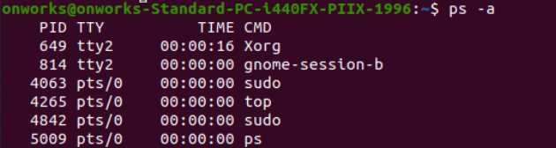
.
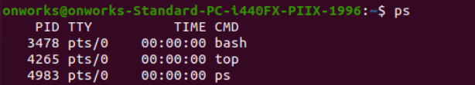
.
.
VIM EDITOR CONCAT:

.
.
.
.
.
.
.





